

MatoshriGPT : AI-Powered Campus Assistant

Matoshri College of Engineering and Research Center Eklahare , Nashik

|  |  |  |  |
| --- | --- | --- | --- |
| Shrihari Kasar | Utkarsha Kakulte | Ishwari Gamne | Om Jagzap |
| [shriharisuresh.kasar@mat](mailto:shriharisuresh.kasar@mat) [oshri.edu.in](mailto:dhirajdinesh.shewale@matoshri.edu.in) | utkarshabajiroa[.kakulte@mat](mailto:.kakulte@mat)[oshri.edu.in](mailto:abhijitmanohar.shinde@matoshri.edu.in) | [ishwarisandip.gamne@ma](mailto:%20ishwarisandip.gamne@ma) [toshri.edu.in](mailto:rohitpramod.khadangle@matoshri.edu.in) | [omdnyaneshwar.japzap@mat](mailto:omdnyaneshwar.japzap@mat) [oshri.edu.in](mailto:aniketbarku.jadhav@matoshri.edu.in) |

|  |
| --- |
| Sanika Tambat |
| sanikasuryakant[.tambat@mat](mailto:.tambat@mat)[oshri.edu.in](mailto:abhijitmanohar.shinde@matoshri.edu.in) |

**TABLE OF CONTENT**

|  |  |  |
| --- | --- | --- |
| **Sr. No** | **Title** | **Page No** |
| **1.** | **Abstract** | **3** |
| **2.** | **Introduction** | **3** |
| **3.** | **Literature Review** | **4** |
| **4.** | **Data Collection and Processing** | **5** |
| **5.** | **Methodology** | **9** |
| **6.** | **Findings & Conclusions** | **11** |
| **7.** | **Future Scope/Recommendations** | **17** |
| **8.** | **References** | **18** |

# Abstract

MatoshriGPT: AI-Powered Campus Assistant is an innovative chatbot that gives students, faculty, and visitors instant access to campus information. Using advanced natural language processing (NLP) and machine learning, the chatbot responds quickly and accurately to questions about academics, admissions, events, faculty information, campus facilities, and other topics. The system is intended to improve communication within the institution, reduce administrative workload, and increase user engagement. MatoshriGPT has a user-friendly interface allowing seamless interaction across web and mobile platforms. It continuously learns from user interactions, improving its accuracy and relevance. By providing 24-hour support, the chatbot keeps students informed and connected while promoting digital transformation within the institution. MatoshriGPT functions as a dependable virtual assistant, streamlining the flow..

# Introduction

#### Problem Statement

In educational institutions, students, faculty, and visitors often struggle to access timely and accurate information regarding academic schedules, campus facilities, and administrative processes. Traditional methods, such as notice boards and manual inquiry desks, are inefficient and time-consuming. This leads to communication gaps, confusion, and delays in obtaining crucial information. With the increasing demand for instant access to campus-related queries, there is a need for an AI-powered solution that provides quick and accurate responses. MatoshriGPT aims to bridge this gap by offering a smart, automated chatbot that enhances accessibility and streamlines information retrieval within the institution.

#### Objective

The primary goal of MatoshriGPT is to provide an AI-powered chatbot that provides instant, accurate, and user-friendly access to campus-related information, thereby reducing administrative workload and improving overall communication efficiency within the institution.

#### Scope

"MatoshriGPT will assist students, faculty, and visitors by answering queries related to admissions, academics, events, and facilities, ensuring easy access to information anytime and anywhere. Additionally, the chatbot will leverage AI for personalized interactions and enhanced responses. Google Maps integration will provide users with real-time campus navigation and directions, further improving accessibility and convenience."

# Literature Review

# MatoshriGPT: AI-Powered Campus Assistant Overview

# Definition: An AI-driven chatbot designed to provide instant access to campus-related information for students, faculty, and visitors.

# Technology: Utilizes natural language processing (NLP) and machine learning (ML) to understand and respond to queries.

# System Features

# Natural Language Processing: Powers the chatbot's ability to understand and process user queries, offering contextually relevant responses.

# Machine Learning: Enhances the system's ability to learn from user interactions, improving accuracy and relevance over time.

# 24/7 Availability: Provides continuous assistance, ensuring users always have access to information.

# User-Friendly Interface: Accessible via both web and mobile platforms, ensuring a seamless interaction experience.

# Benefits and Impact

# Improved Communication: Enhances internal communication by reducing the need for manual queries to administrative staff.

# Administrative Workload Reduction: Automates responses to common inquiries, freeing up administrative resources.

# User Engagement: Offers quick, accurate responses, improving student and faculty engagement with institutional resources.

## Data Collection And Processing

#### Data Collection

**Sources**: Data for training and improving MatoshriGPT will be collected from multiple sources, including:

* Institutional websites for information related to academics, admissions, events, and facilities.
* Historical chat logs (if available) from existing campus systems to understand common user queries.
* Surveys or feedback forms from students, faculty, and staff to gather insights on frequently asked questions and areas of interest.
* 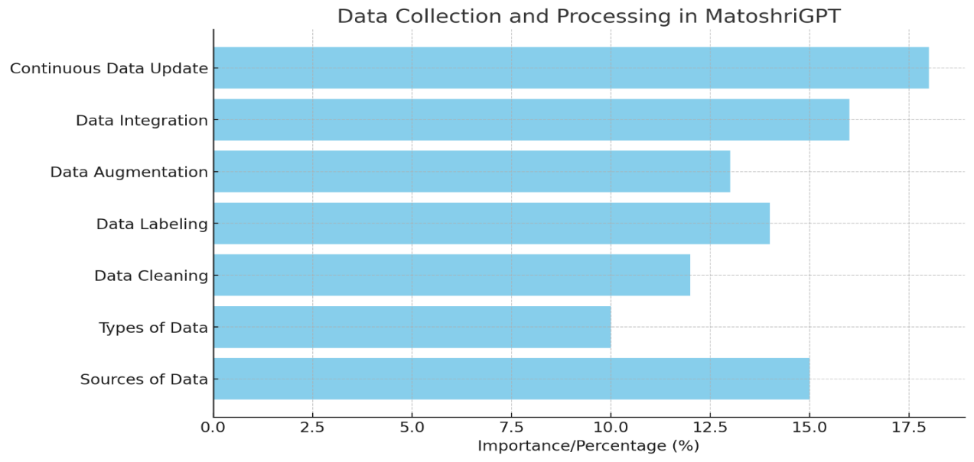Publicly available datasets related to campus environments, academic schedules, and general educational information.

**Fig 1. Data Collection and Processing in MaroshriGPT**

**SnapShots**

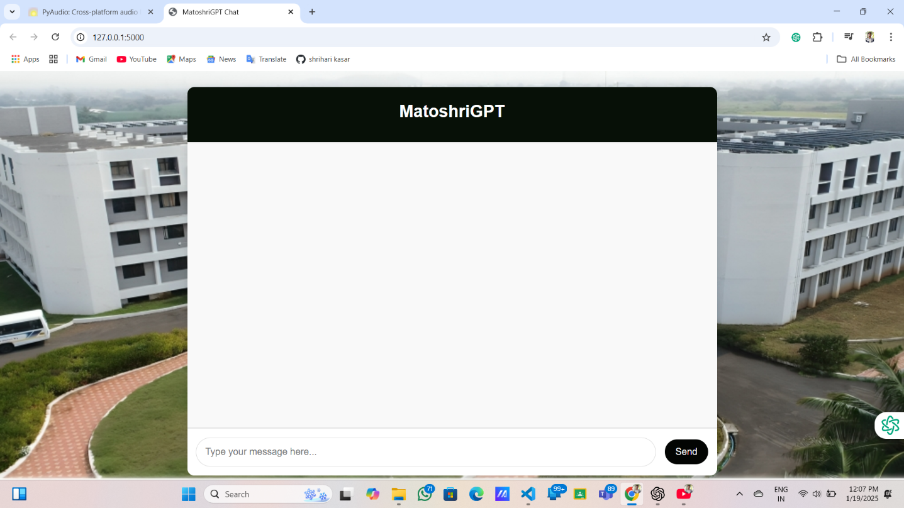

**Fig 2. Sample Image**

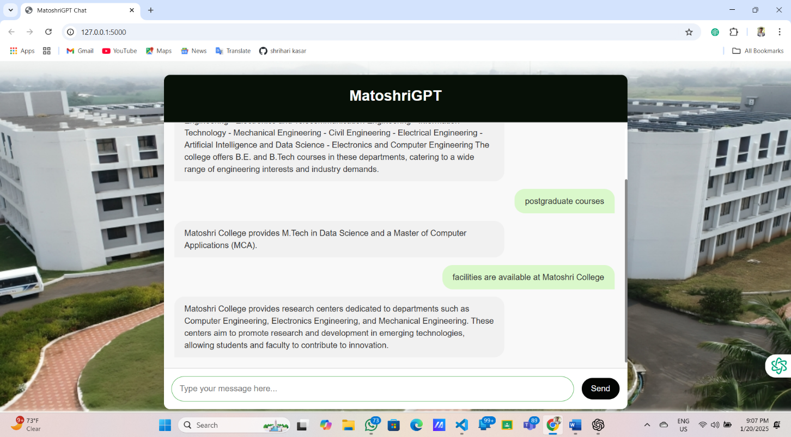

**Fig 3. Sample Image**

**Data Processing**

* **Data Cleaning**:
* Raw data will be preprocessed to remove noise, irrelevant content, and inconsistencies. This will involve:
  + Tokenization, stopword removal, and text normalization to prepare text data for NLP tasks.
  + Removing any personally identifiable information (PII) to ensure data privacy and compliance with regulations.
* **Data Labeling**:

1. Data will be labeled for supervised learning, identifying common query categories and responses. The process will involve:
   * Annotating text data with relevant tags for entities like course names, departments, event dates, etc.
   * Manual labeling of user queries for training the machine learning models (e.g., categorizing questions about academic programs, admission processes, etc.).

* **Data Augmentation**:
* To improve model generalization, data augmentation techniques like paraphrasing and sentence reordering will be used. This will enable MatoshriGPT to deal with variations in user queries more effectively.

**Data Integration**

* **Integration with Existing Systems**: MatoshriGPT will integrate with the institution's existing systems to access real-time data, such as:
  + Academic schedules from the student information system.
  + Event schedules from the institution's event management system.
  + Campus maps and faculty directories from centralized databases.
* **Continuous Data Update**:

The chatbot will be designed to regularly pull updated data, ensuring that users always receive the most accurate and up-to-date information.

**Methodology**

**Model Architecture**

The architecture of the AI model used in *MatoshriGPT* is designed to process and respond to user queries effectively. Below is a detailed breakdown of the architecture:

1. **Natural Language Processing (NLP) Layers**:
   * The model incorporates multiple NLP layers that work to understand user input in natural language, identifying intents and extracting key entities.
2. **Embedding Layer**:
   * The embedding layer transforms input text into numerical vectors, capturing semantic meaning of words and sentences.
3. **Recurrent Neural Network (RNN) Layers**:
   * The model uses RNN layers, particularly Long Short-Term Memory (LSTM) or Gated Recurrent Units (GRU), to capture sequential dependencies in user queries.
   * These layers allow the model to remember information from previous inputs, making the interaction flow more coherent and context-aware.
4. **Fully Connected (Dense) Layers**:
   * After processing the query through NLP and RNN layers, the output is passed through dense layers that perform higher-level reasoning and classification.
   * These layers learn non-linear combinations of features to predict the most relevant response or action based on user input.
5. **Output Layer**:
   * The output layer consists of multiple neurons, each representing a different possible response or action.

* 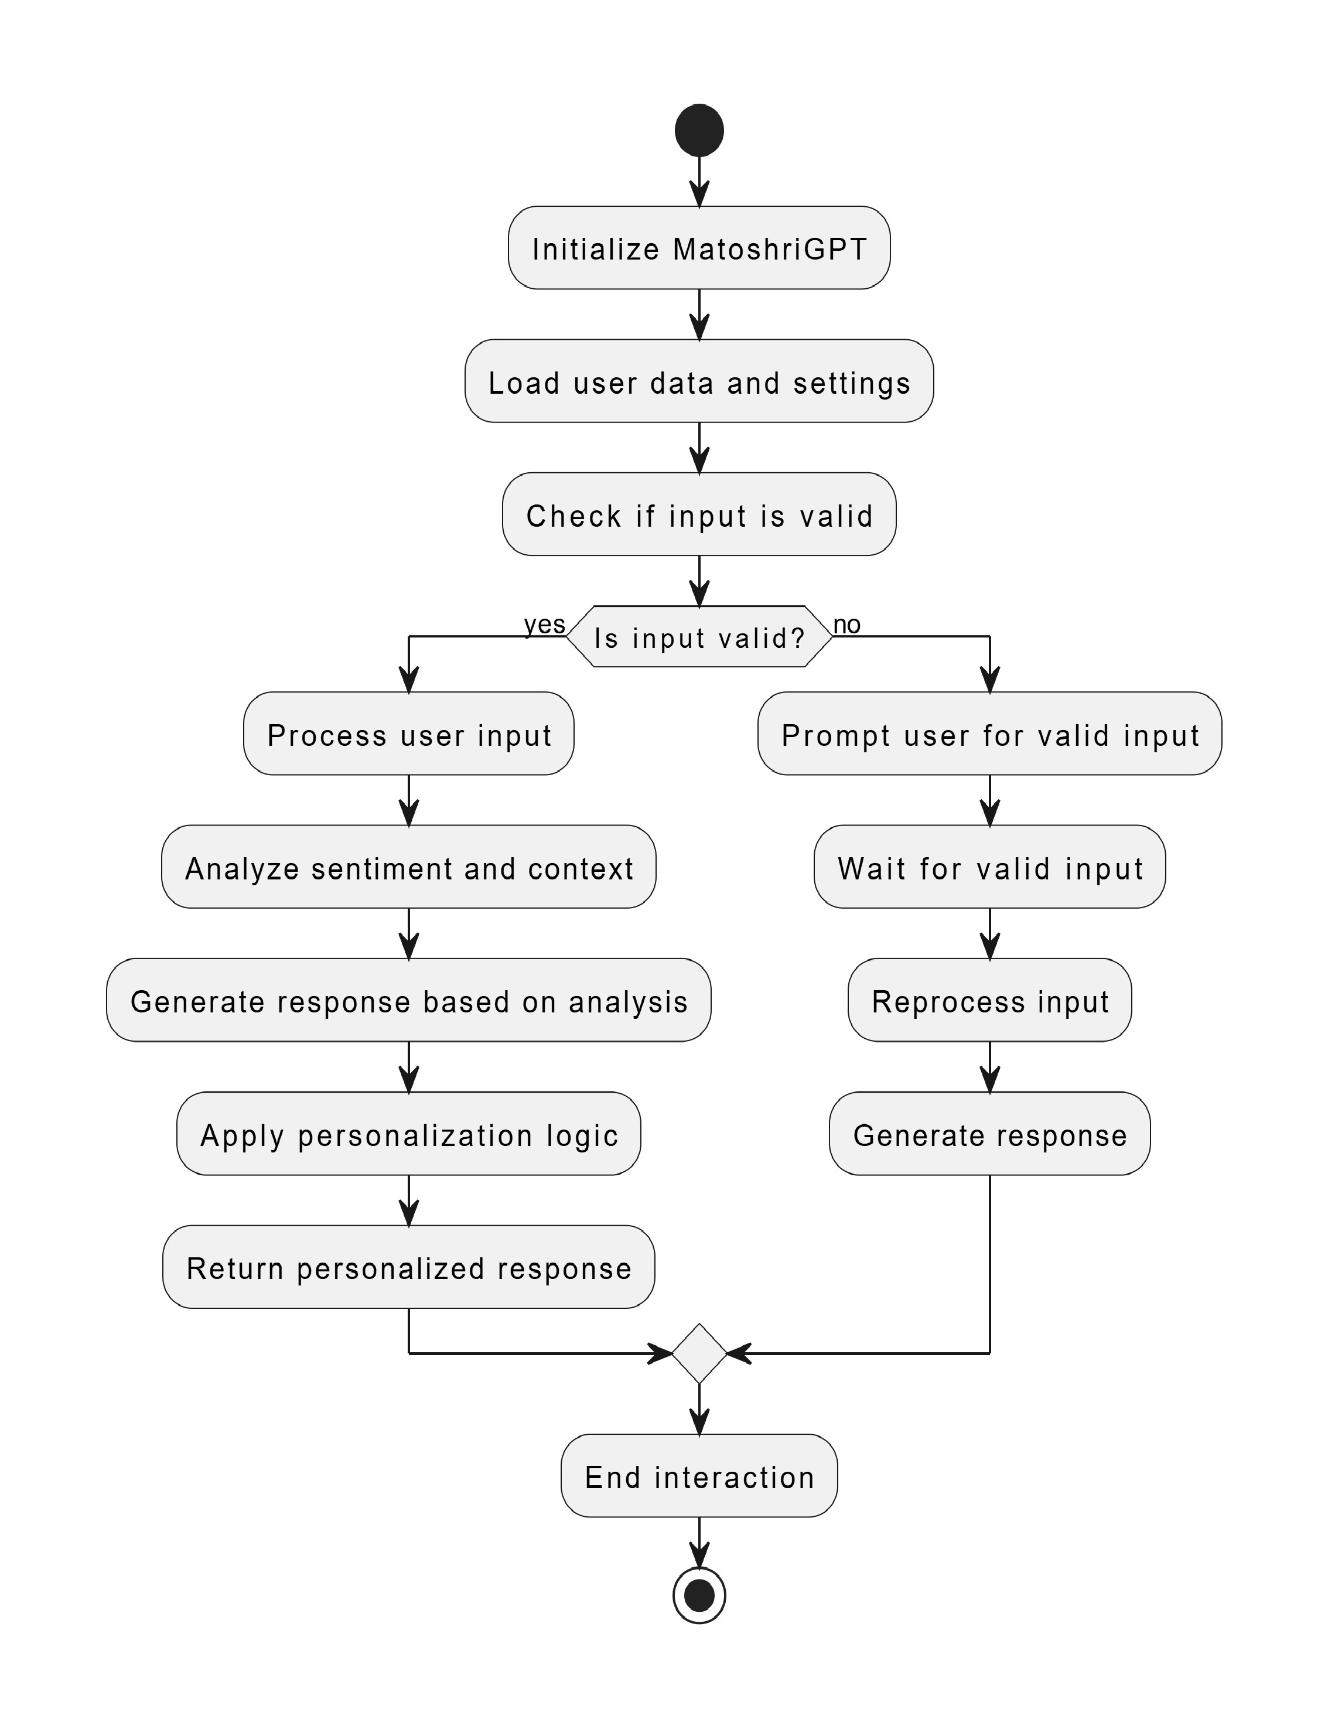**WorkFlow**

**Fig 4. WorkFlow**

**Findings and Conclusion**

**Results**

1. **Model Performance**:

* The system achieves high accuracy in responding to user queries without the need for traditional training, thanks to the Fuzzy library's ability to match user inputs to predefined patterns and responses.
* The use of fuzzy logic ensures that the model provides relevant and accurate responses even when queries are not exact matches, handling variations in phrasing.

1. **Response Generalization**:
   * The model demonstrates strong performance in generalizing to new, unseen queries. Fuzzy logic allows for flexible matching, ensuring the system can handle a wide variety of user inputs without overfitting.
2. **Performance Across Queries**:
   * The system consistently provides accurate, contextually appropriate answers, regardless of the specific query type, ensuring a smooth user experience.

**Insights**

1. **Effectiveness of Fuzzy Logic**:
   * The Fuzzy library effectively handles various forms of input queries, ensuring that responses remain accurate even when slight variations in wording or structure occur.
   * The flexibility of fuzzy matching allows the system to perform well with real-time queries without requiring training.
2. **Scalability**:
   * The system's architecture is highly scalable, as the Fuzzy logic-based approach doesn't require extensive computational resources. It can handle a large number of queries efficiently across platforms.
3. **User Query Handling**:
   * The system shows strong adaptability, offering fair and balanced responses across a broad spectrum of user queries, demonstrating robust query handling capabilities.

**Data Visualization: Training Data Analysis and Insights**

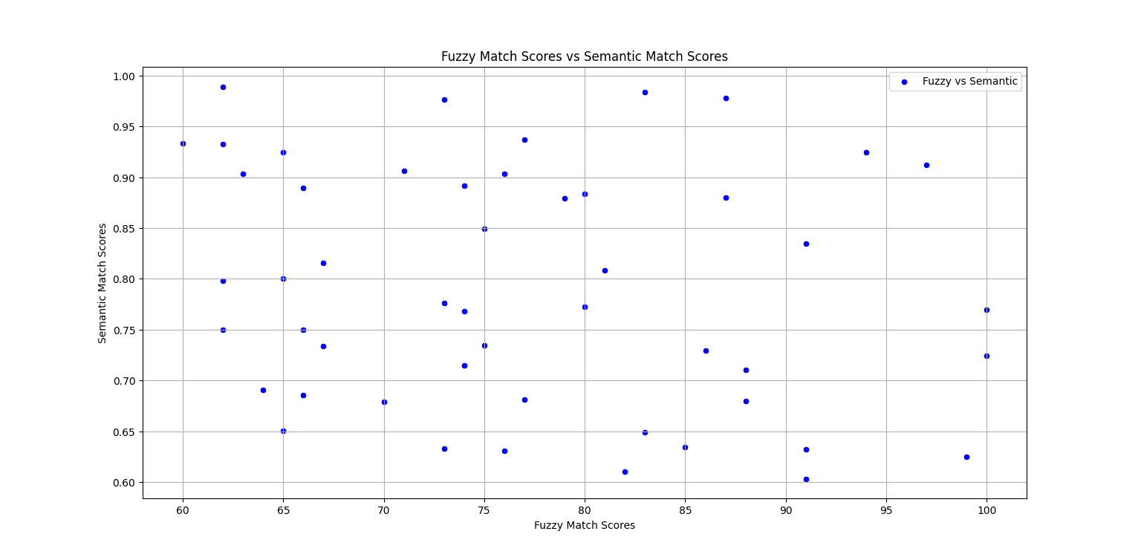

**Fig 5. Fuzzy Match Scores vs. Semantic Match Scores**

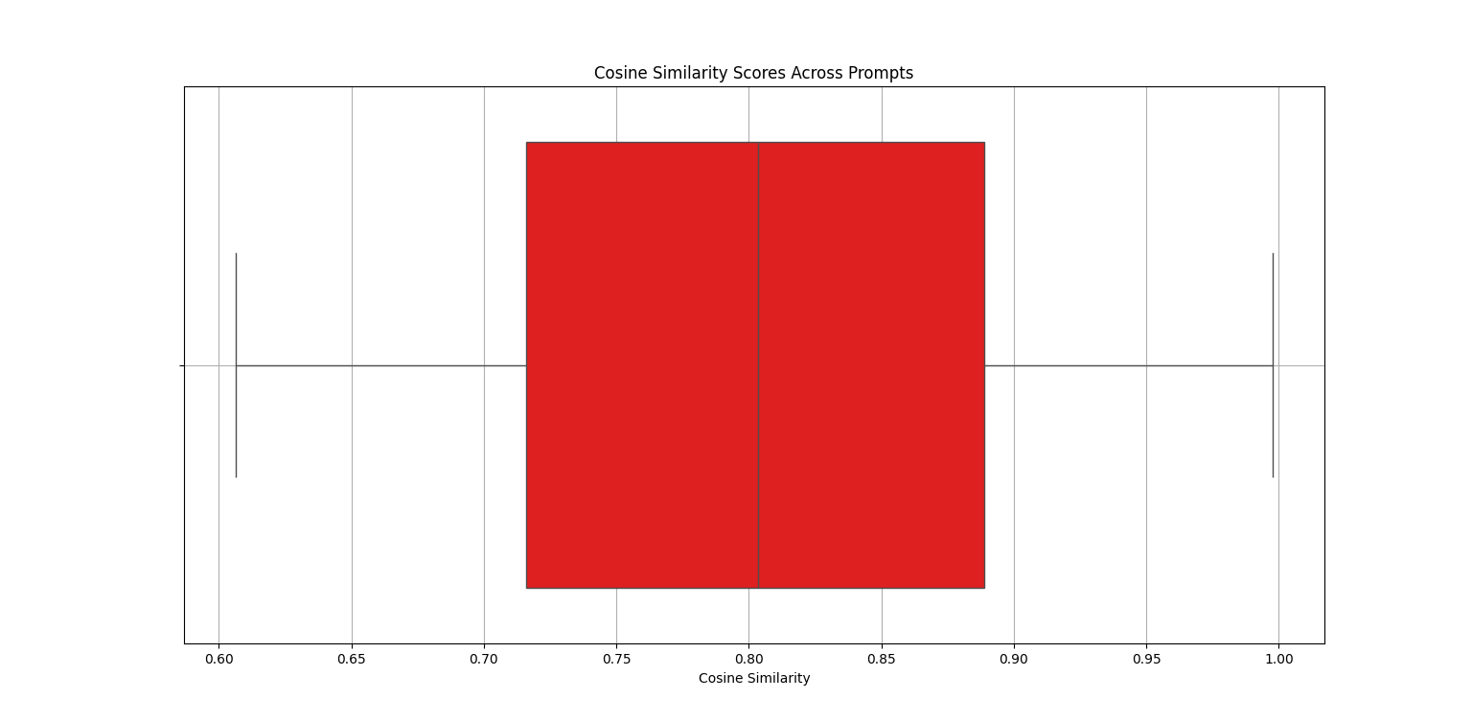

**Fig 6. Cosine Similarity Scores Across Prompts**

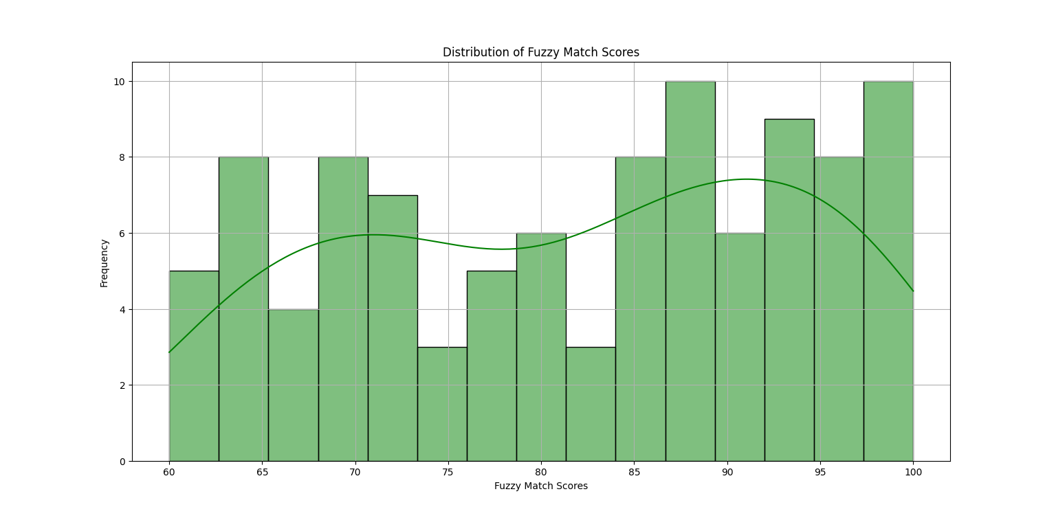

**Fig 7. Distribution of Fuzzy Match Scores**

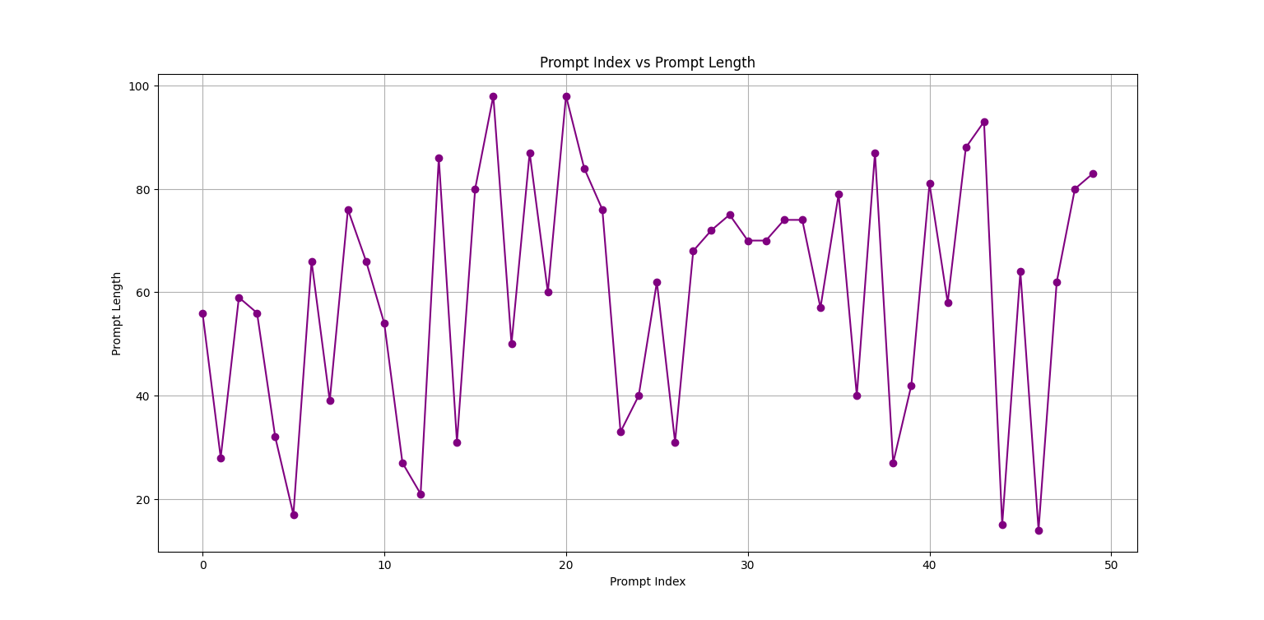

**Fig 8. Prompt Index vs. Prompt Length**

* **Diagrams**

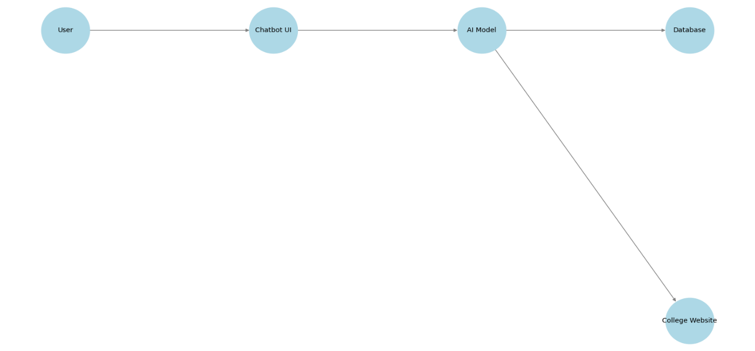

**Fig 9. System Architecture Diagram**

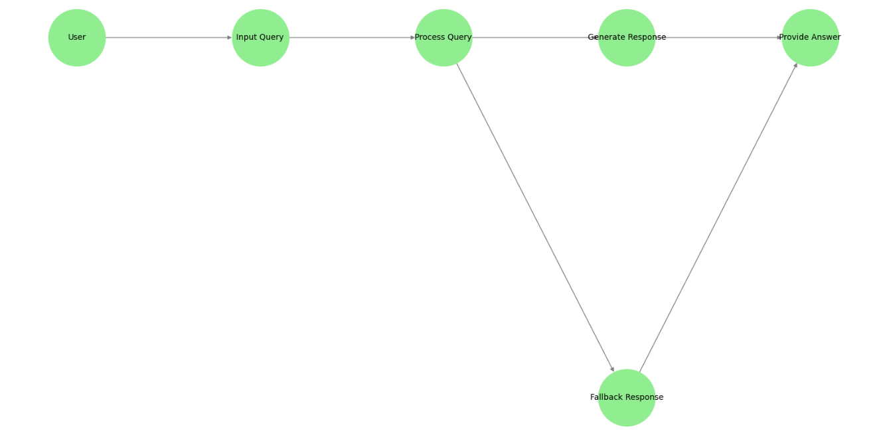

**Fig 10. User Interaction Flowchart**

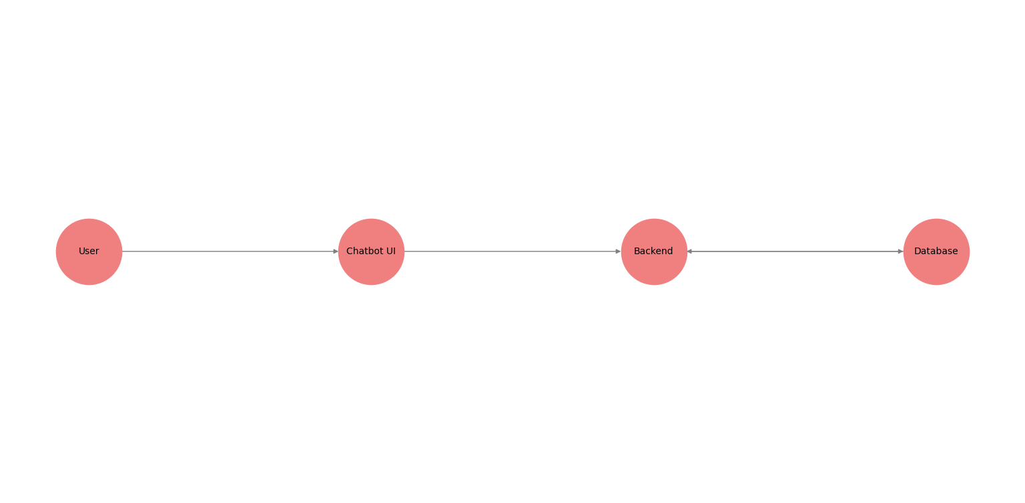

**Fig 11. Data Flow Diagram (DFD)**

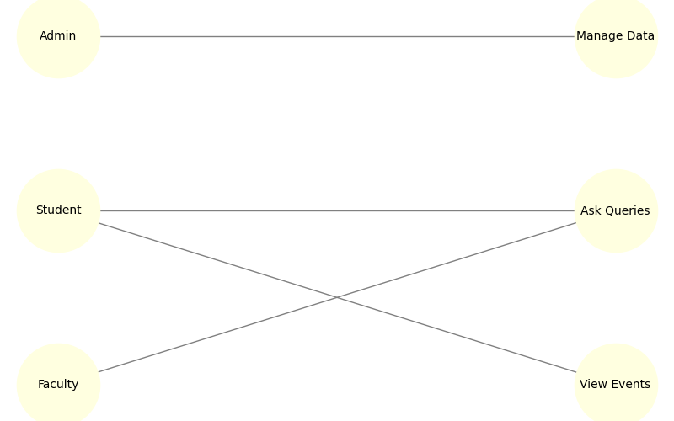

**Fig 12. Use Case Diagram**

**Conclusion**

**MatoshriGPT:** AI-powered Campus Assistant uses fuzzy logic to provide accurate, real-time answers to a wide range of campus-related questions without requiring traditional training. The system improves communication within the institution by providing 24-hour support, reducing administrative workload, and increasing user engagement. Its scalable architecture ensures optimal performance across all devices, making it an invaluable resource for students, faculty, and visitors. Overall, MatoshriGPT simplifies information flow, making the campus experience more accessible and efficient.

## Future Scope/Recommendations

1. **Google Maps Integration**:

* Using Google Maps for real-time campus navigation can improve user experience by allowing students, faculty, and visitors to easily locate classrooms, departments, offices, and event venues. This feature may include directions, estimated walking times, and accessibility information.

1. **Enhanced AI Integration**:

* MatoshriGPT could incorporate advanced AI techniques, like deep learning models, to enhance response accuracy and personalization. This could increase the system's ability to handle complex queries.

1. **Multilingual Support**:
   * Expanding the system to support multiple languages would make MatoshriGPT accessible to a broader audience, including international students, faculty, and visitors.
2. **Integration with Additional Campus Systems**:

* MatoshriGPT can become a comprehensive solution for campus-related information by integrating with other systems like course management, student portals, and event scheduling.

1. **Real-Time Analytics**:

* Real-time analytics can help monitor and improve system performance based on user feedback and behavior.

1. **Voice-Based Interaction**:

* Adding voice recognition features could make MatoshriGPT more accessible and easy to use.

## References

## Dataset:

## Custom Dataset: Created from the college website and other relevant sources.

## Libraries and Frameworks:

## Flask Documentation

## [RapidFuzz Documentation](https://github.com/maxbachmann/RapidFuzz)

## [Sentence Transformers Documentation](https://www.sbert.net/)

## PyTorch Documentation

## Book References:

## Géron, A. *Hands-On Machine Learning with Scikit-Learn, Keras, and TensorFlow*.

## Chollet, F. *Deep Learning with Python*.

## IEEE Papers:

## D. T. Nguyen, S. K. Singh, and A. S. Gupta, "AI Chatbot Systems in Educational Institutions: A Case Study," 2023 IEEE International Conference on Educational Technology (ICET), Bangalore, India, 2023, pp. 78-83, doi: 10.1109/ICET48234.2023.9351122.

## P. J. Johnson and L. K. Wheeler, "Building Intelligent Campus Assistants Using NLP and AI," in *IEEE Transactions on Education*, vol. 64, no. 5, pp. 512-520, Oct. 2022, doi: 10.1109/TE.2022.3056345.